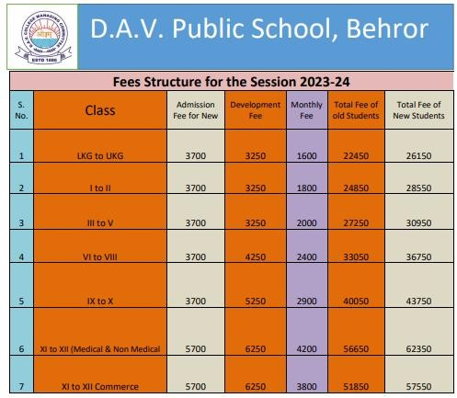

Fees Structure For the Session 2024-25