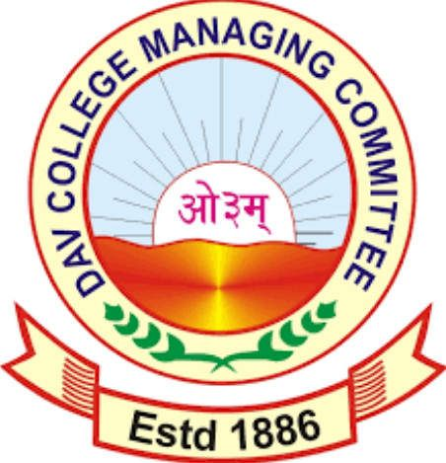
Sr. No…………
ओउम् ओउम् D.A.V. PUBLIC SR. SEC. SCHOOL, BANKHANDI TEH. HARIPUR, DISTT. KANGRA (H.P.) – 177114
Affix Latest Photograph
(Managed by D.A.V. College Managing Committee, New Delhi)
(Email-id: davban@rediffmail.com, Website: www.davbankhandi.in)
- Post Applied For: ___________________________ DAV CBT: Yes No
- Name of the Candidate (In Block Letters): _____________________________________
- Father’s/Husband’s Name: _________________________________________________
- Date of Birth: ___________________________________________________________
- Marital Status: ___________________________________________________________
- STET/CTET: Yes No
- Educational Qualification:-
Sr. No. | Exam Passed | Year | Stream | Subject | Board/  University | Name of Institution | Marks Obtained | %age (Total)
1 | 10TH
2 | 12TH
3 | Graduation
4 | Post-Graduation
5 | B.Ed.
6 | JBT/D.El.Ed/Bridge Course
7 | NTT
8 | Any Other

- Professional/Teaching Experience:-
Sr. No. | Name of Institution | Designation | From | To | Status
1
2
3

- Address: _______________________________________________________________

_______________________________________________________________________

Contact No. __________________________ Email-ID __________________________
- If you do not belong to Nearby station
will you commute daily? ___________________________________
- Please mention various fields where
you can prove useful to the school,
besides your duties. ___________________________________
- If you have School going children
do you have satisfactory arrangement
to look after them while you are on duty? ___________________________________
- Can you go out of station on school duty? ___________________________________
- Can you devote extra time before/after
the school hours? ___________________________________
- Can you devote time on holidays? ___________________________________
- Local reference with address. ___________________________________
- Minimum salary acceptable. ___________________________________
- Can you speak and teach in English fluently? ___________________________________
- Related extra-curricular activities.
(If any specify) ___________________________________
- Any other remarks. ___________________________________
_______________________________________________________________________
- If selected when will you join the school? ___________________________________
- Relate yourself with your subject.

Date: Signature of the candidate

Place:

Note: 1. Testimonials in original must be produced at the time of interview.
2. No TA/DA shall be paid to attend the interview.

